Paper No: SID-ME Template for a 2-page camera-ready abstract
(replace this text with your paper title. Leave the Paper No unchanged. This will be added after submission.)
John Doe*, S'chn-T' Gaii Spock*, Albert Bernstein**, Michiel Van Dousselaere *,**
*University of Vienna, Austria, **Märklin, Germany

Abstract
A 50-word abstract announcing the essential scope, methods and results of this work was written. It explains the relevance of the work, its originality and the main highlights. Compared to the average template, ours has the advantage of being particularly clear, twice as funny and 3x more pleasant to read.

1. Introduction
Recently, the use of templates for the submission of abstracts, extended abstracts or full papers to conferences has become standard procedure. The advantage is that the visual appearance of the proceedings of such a conference is more uniform, which makes them easier to navigate. It also makes the job of the editor of these proceedings easier.
Such a template, which is typically provided by the conference organizer, usually contains some bogus text that is used as a placeholder for the actual manuscript to be submitted by the authors that will use the template. While being very useful, this placeholder text is not very pleasant and sometimes even boring to read. Sometimes it contains a repetition of the following nonsensical, seemingly Latin text [1]:
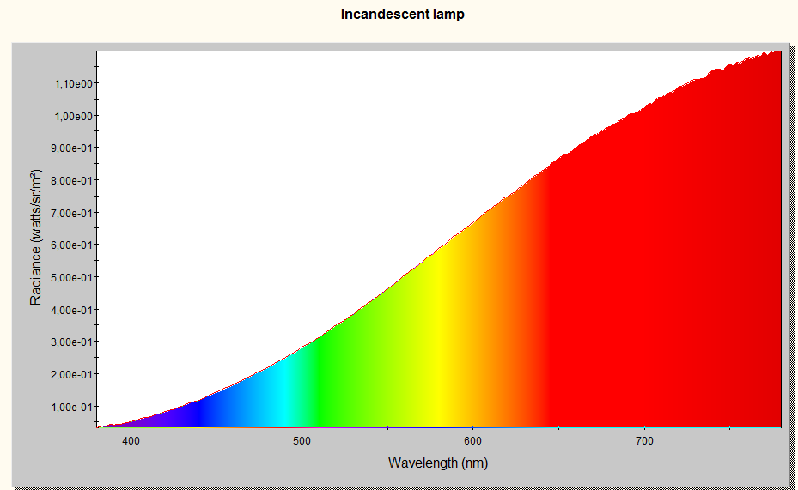
“Lorem ipsum dolor sit amet, consectetur adipisicing elit, sed do eiusmod tempor incididunt ut labore et dolore magna aliqua. Ut enim ad minim veniam, quis nostrud exercitation ullamco laboris nisi ut aliquip ex ea commodo consequat. Duis aute irure dolor in reprehenderit in voluptate velit esse cillum dolore eu fugiat nulla pariatur. Excepteur sint occaecat cupidatat non proident, sunt in culpa qui officia deserunt mollit anim id est laborum.”
Fig. 1 Visible spectrum of a very special lamp. This figure and its caption are ‘grouped’ in order to keep them together, If grouping is not possible you can put your figure and caption together in a text box. In both cases set the text wrapping of the resulting combination to ‘Top and bottom”. Figures can span 1 or 2 columns as needed.

Sometimes, some other text is repeated over and over again, with the same boring result.
In this 2-page template we will demonstrate that it is possible to have text that serves the purpose of ‘placeholder’ while at the same time being entertaining and pleasant to read.

2. Methods

2.1 Content
In order to produce a text that is pleasant to read and is still useful for acting as a placeholder, we have used the following approach:
- First, we have written this text as if it was the text of an actual scientific paper, i.e. we used exactly the same style of writing, including Latin abbreviations for things such as e.g. ‘for example’
- Secondly, the structure of the text is built up in a manner that approximates a normal paper as much as possible. This means that first an introduction is given, subsequently the methods are described and , the results are given, followed by a discussion and some conclusions
- Typographical features such as bulleted text and emphasized text in italics are used when appropriate
- The text we have produced is self-referring and sometimes even self-recursive, i.e. it presents to the reader information about the text or even sometimes the sentence he is reading. We believe that this is one of the major instruments to make the text more funny. Self-recursive sentences often cause smiles because they are surprising and intriguing in a funny manner. Some examples will be presented in the section about the results.
This approach yields a text that is equivalent to a normal article as far as typesetting and layout is concerned, while at the same time being perfectly readable.

2.2 Length
One of the difficulties in any paper is the control of the length of the text. Usually very strict rules are implied. For example, in this template we are forced to stay within 2 pages.
One method to do this is to tune the level of detail to which the topics are described. For example, in the description of the content above, we had the option of being very detailed about the typographical features that are used in this template, but we chose to limit ourselves to two examples, because that is enough to make the point while it limits the number of spent characters.
Another method that we can use to adjust the length of the abstract is to scale the pictures. Many pictures are very tolerant to sizing and it is easy to accommodate for 100 words extra by reducing the size of just one picture. Conversely it is possible to approach the 2-page limit more closely by stretching some of the pictures just a little.
See for example Error: Reference source not found for an example of a figure that can be stretched or reduced 10% in size without affecting readability of the manuscript. However, note that the text on the axes is too small, which means it is unacceptable for publication.

3. Results

3.1 Reading behavior
The present template was shown to a test panel of 500 people from different areas in science and their reading behavior was monitored. A standard template was used as a reference. In 250 cases the standard template was presented to the readers prior to the new template; in the remaining 250 cases the order was reversed.
Regardless of the order in which the templates were presented, the new template yielded mild to pronounced symptoms of amusement, while the conventional template yielded no noticeable emotions. While reading the self-recursive sentences ‘This sentence contains ten words, eighteen syllables and sixty-four letters.’ [2] and ‘In this sentence, the word "and" occurs twice, the word "eight" occurs twice, the word "four" occurs twice, the word "fourteen" occurs four times, the word "in" occurs twice, the word "seven" occurs twice, the word "the" occurs fourteen times, the word "this" occurs twice, the word "times" occurs seven times, the word "twice" occurs eight times, and the word "word" occurs fourteen times.’[3] a raised attention level was noticed in 92% of the test persons. In 85 % of the test persons this coincided with a clear smile on their face.

3.2 Perseverance
In addition to the amusement and attention level also an increased perseverance to read the remainder of the text was observed. We believe that this is due to the generation of an increased ‘expectance level’, i.e. the induced expectance that something interesting is still to come and it is worth the trouble going through the remainder of the text in order to discover what that might be.

3.2 General appreciation
The detailed processing of the test results will be presented during the conference, but we can already disclose that the new template has proven to be 2.1 times funnier and 2.9 times more pleasant to read than a regular conference template.

4. Discussion

4.1 Merit
As mentioned above, the readability of standard conference proceeding & abstract templates is relatively poor. Often bogus text (sometimes in pseudo Latin) is used as a placeholder for typographical purposes only. We have managed to create a template that serves the same purpose but at the same time is pleasant and interesting to read. Because the new template is more entertaining, it has added value compared to the conventional templates.

4.2 Impact and further research
The expected impact of the new template is twofold. First of all, it is expected to take away some of the stress inherent to the writing of an article; secondly it is expected act as an incentive for people hesitating to write down their results. These second-order results merit further investigation which we will report in future publications.

5. Conclusion
A new template for conference proceedings was created. Instead of using bogus text or pseudo-Latin phrases, the text is readable, entertaining and sometimes even funny due to its self-recursive nature. We expect that his template will have a positive impact on the number of authors submitting their work for publication

References
[1] http://en.wikipedia.org/wiki/Lorem_ipsum
[2] Hofstadter, D. R. "On Self-Referential Sentences," "On Self-Referential Sentences: A Follow-Up," and "On Viral Sentences and Self-Replicating Structures." Chs. 1-3 in Metamagical Themas: Questing of Mind and Pattern. New York: BasicBooks, pp. 1-69, 1985.
[3] Howard W. Bergerson, “Palindromes and Anagrams”, Jun 1, 1973.

Remove this line, but not the Continuous Section Break above it, because it keeps the columns on the last page of equal length.

